**Treasure Island**

1. Delete Sprite 1 (the cat)
2. Create the following Background as a bitmap (not a vector).

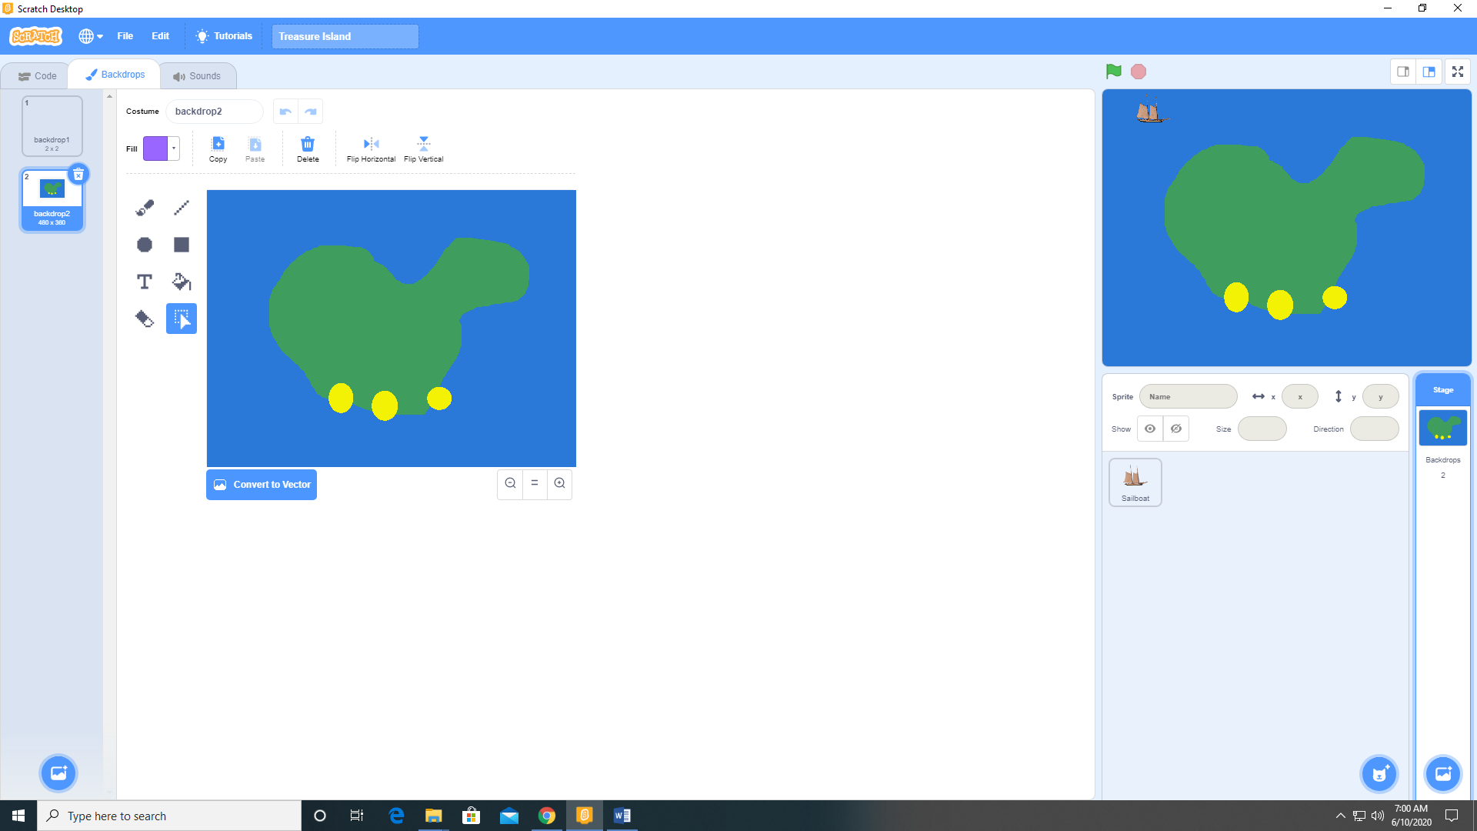

1. Add a sprite (I used Sailboat). Scale it to 20%

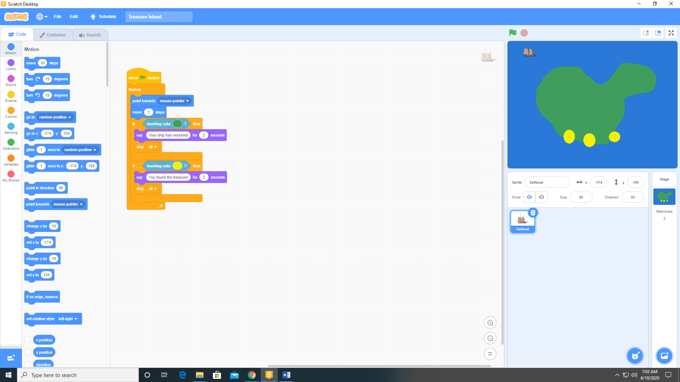

1. Add the following code to the Sailboat sprite.

